Styal Tennis Club Spring 2017 newsletter

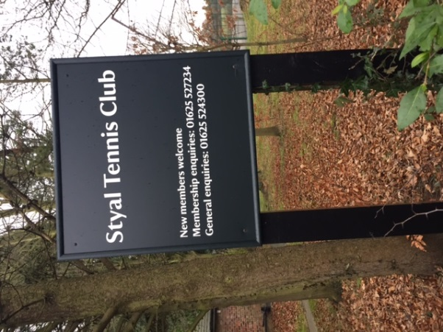
Club house upgrade
As we head into 2017, hopefully you have all seen the fantastic new look of our club house! Many thanks to everyone who has been involved in getting to this point. Further work has been agreed by the Committee for the coming season – watch this space!
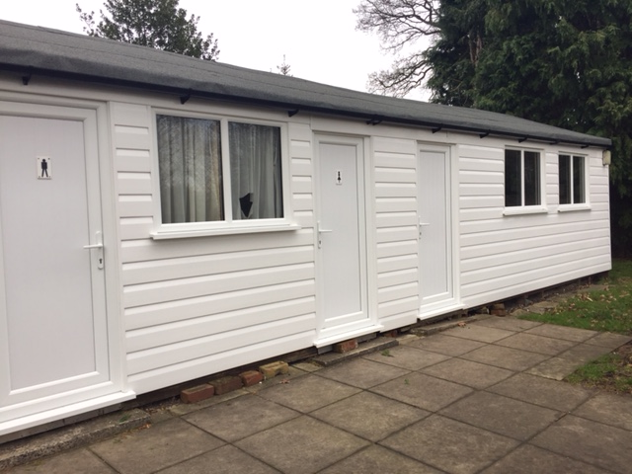

Spring clean up
2nd April from 10am – please try and come along, many hands make light work and it is important that we make the club house and grounds ready for the busy season ahead.

American tournaments / open days
This year we have combined 2 open days with American tournaments. This will make sure that visitors will see STC at its busy, vibrant best with lots of friendly tennis being played. The dates have been set as follows:
  - April 23rd – also an open day
  - May 14th – also an open day
  - June 11th
  - July 16th
  - August 13th
  - Sept 17th – Ken Davis trophy
  - Oct 15th
  - Dec 10th – 1pm start
Our American tournaments start at 2pm, cost £2.50 and there is a prize for the top scoring man & woman. There is a rota in the clubhouse for organising each event and providing the prizes and refreshments. It is important that these roles are shared among members so please do pick a date and sign up! Many hands make light work (again).

Club days
Club days continue throughout the year on Wednesdays and Sunday afternoons from 2pm and on Thursday evenings in the summer from 6:30pm. The men play on a Saturday from 10am but ladies are also welcome. Why not come along and enjoy some good social tennis?
Matches!
- Several friendly matches against local teams are being organised in 2017 – watch the notice board for more info.

- We have a men’s team in the North East Cheshire League (division 7) – all men are welcome to play in the team so please put your name on the availability list in the club house or contact Roy Owen. The Club is always looking for new team members so please sign up!

- We also have a team in the Cheshire Winter League – playing mens, womens and mixed matches. They are great fun and a good opportunity to meet other players whilst running around in the cold. Anyone interested should contact Dave Crisp on the committee.

Membership
Yes it’s that time of the year again! Membership subscriptions need to be paid before the season starts on the 1st April, please. After much discussion at the 2016 AGM, there has been a nominal increase in fees and full details will be sent out by the membership secretary, Chris Jackson, over the next couple of weeks.

Lawn Tennis Association
The LTA has a website: www.lta.org.uk which you may wish to visit to view details of our club as well as other tennis news.

The Committee 2017
Chairman John Tomlinson 01625 250812
Treasurer Doug Adams 01625 524300
Membership Chris Jackson 01625 527234
Secretary Helen Clark 0161 439 2319
Team Captain Roy Owen 0161 437 0990
Clubhouse Sandra Adams 01625 524300
Winter league Dave Crisp 07837 796906
Grounds Steve Booth 0161 491 5824
Coaching / marketing Pam Clements 01625 537995
Club Promotion Jackie Poyser 01625 529559

Wishing everyone a great 2017 of tennis!

